National Textile University, Faisalabad


Department of Computer Science
Name | Ghulam Habib
Class | BSSE 3rd
Section | A
Registration No | 24-NTU-CS-FL-1154
Assignment | Lab-7
Course Code | DS-2077
Course Name | Data Structures
Submitted To | Sir Basit
Submission Date | 11-November -2025

DATA STRUCTURES
Lab Plan – 1
Exercise-1:

Exercise-1: Write a function CalculateFactorial which will calculate the factorial of a number. Ask user to input a number and call the CalculateFactorial to calculate the factorial of the number. Use repetition method in the CalculateFactorial function to calculate the factorial

Code :

#include <iostream>

using namespace std;

long factorial(int n)

{

long ans = 1;

for (int i = 2; i <= n; i++)

{

ans *= i;

}

return ans;

}

int main()

{

int facNo;

cout << "Enter the no \n";

cin >> facNo;

long ans = factorial(facNo);

cout << ans << endl;

return 0;

}

Screenshot :
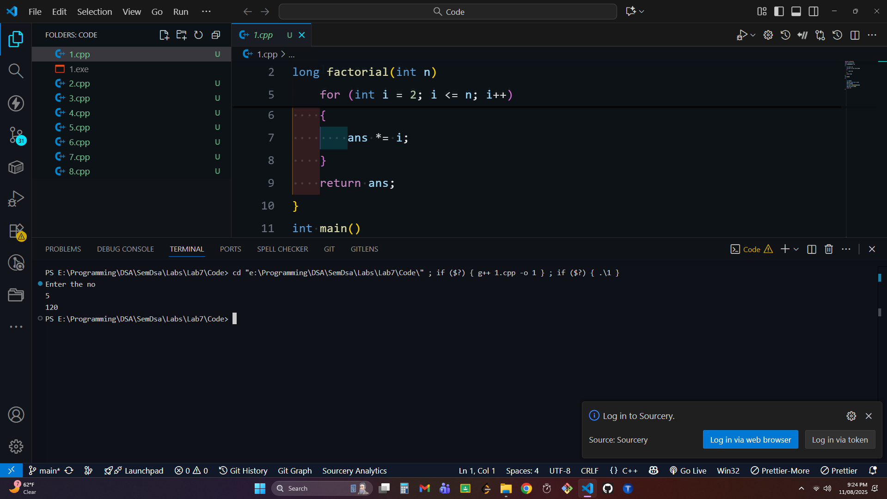

Exercise-2:

Now write a function FactorialRecursion which will calculate the factorial of the number using recursion.

Code :

#include <iostream>

using namespace std;

long factorial(int n)

{

if(n==1||n==0)

{

return 1;

}

long ans=n*factorial(n-1);

return ans;

}

int main() {

int n;

cout<<"Ente the No \n";

cin>>n;

long ans=factorial(n);

cout<<ans<<endl;

return 0;

}

Screenshot :
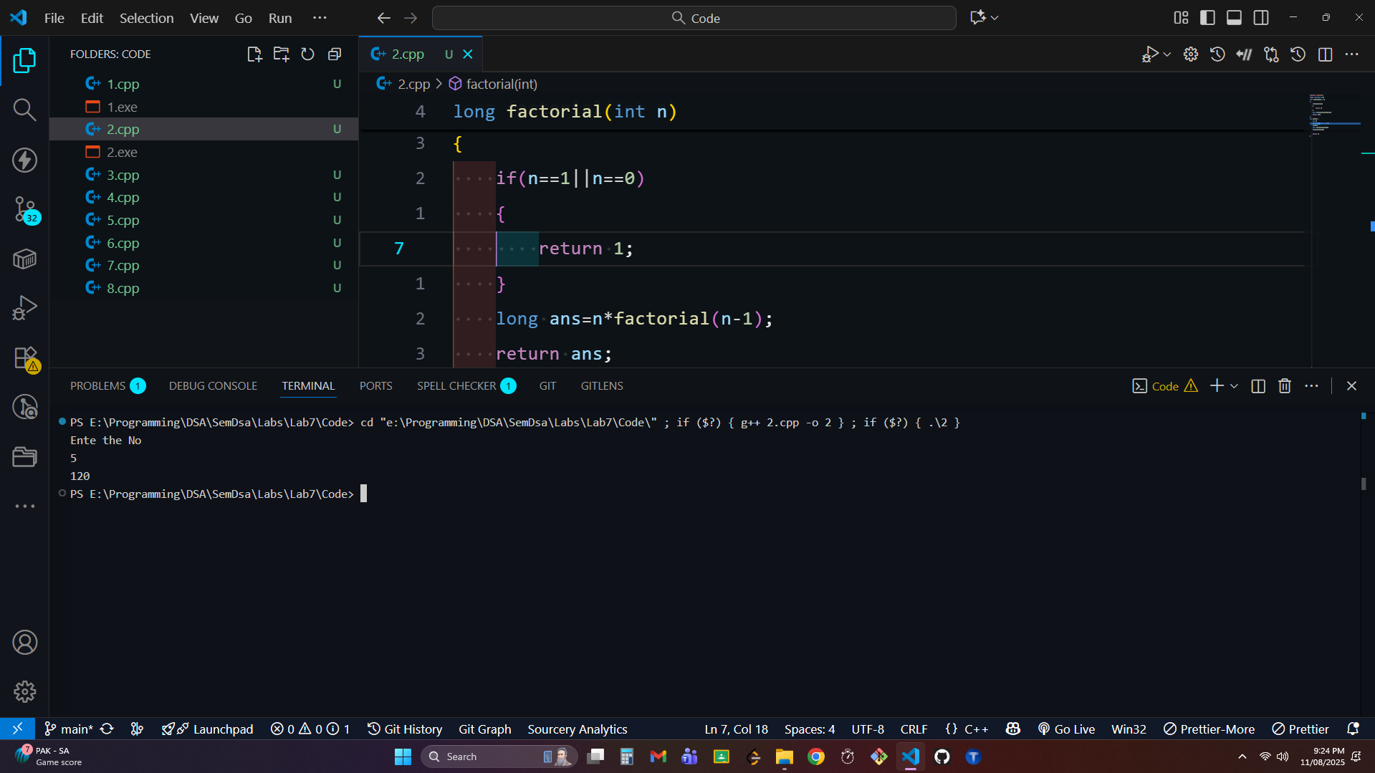

Exercise-3:

Write a function RaiseToPower which will calculate the power of a number up to given limit. Ask the user to get number and power and calculate the power of the number. Use iteration method in the RaiseToPower function to calculate the power.

Code:

#include <iostream>

using namespace std;

int power(int n, int pow)

{

int ans = 1;

for (int i = 1; i <= pow; i++)

{

ans *= n;

}

return ans;

}

int main()

{

int n;

int pow;

cout << "Enter the number \n";

cin >> n;

cout << "Enter the power \n";

cin >> pow;

int ans = power(n, pow);

cout << ans << endl;

return 0;

}

Screenshot :
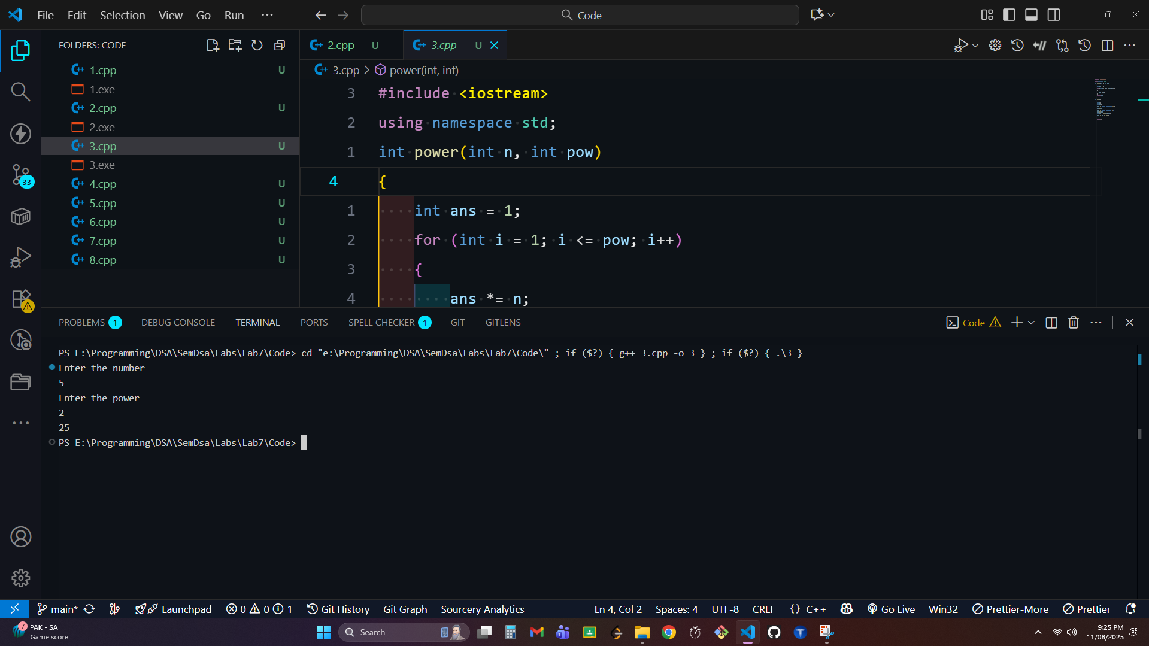

Exercise-4:

Now write another function PowerUsingRecursion which will calculate the power of a number up to given limit. Now use recursion method in the PowerUsingRecursion function to calculate the power.

Code : #include <iostream>

using namespace std;

int power(int n, int pow)

{

if (pow == 0)

{

return 1;

}

if (pow == 1)

{

return n;

}

int ans = n * power(n, pow - 1);

return ans;

}

int main()

{

int n;

int pow;

cout << "Enter the No \n";

cin >> n;

cout << "Enter the power \n";

cin >> pow;

int ans = power(n, pow);

cout << ans << endl;

return 0;

}

ScreenShot :
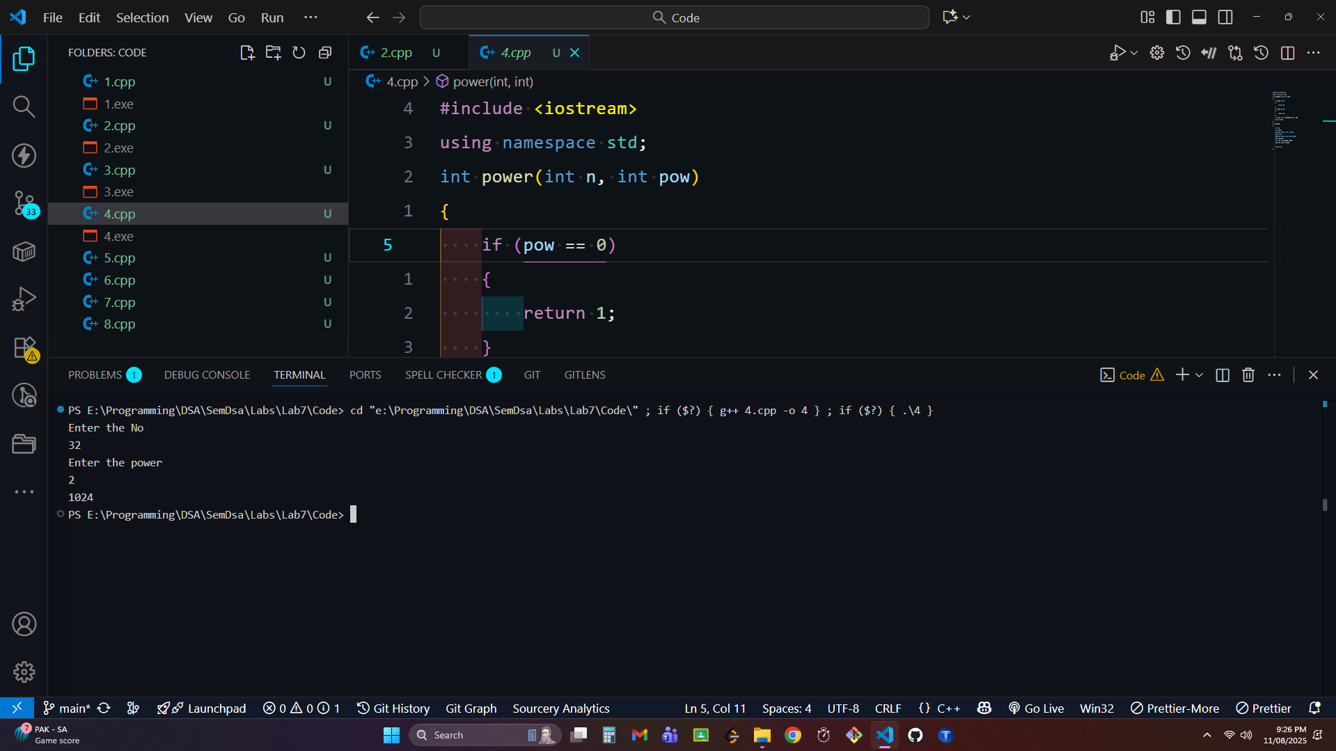

Exercise-5:

Write a function FibonacciSequence which will generate up to the nth term of the Fibonacci sequence. Ask the user to enter a number and display the series up to that number. Use iteration method in the FibonacciSequence function to calculate the series.

Code
#include <iostream>
using namespace std;
int fib(int n)
{
int ans = 0;
int a = 0;
int b = 1;
for (int i = 0; i < n; i++)
{
ans = a + b;
a = b;
b = ans;
}
return ans;
}
int main()
{
int n;
cout << "Enter the fib term no \n";
cin >> n;
int ans = fib(n);
cout << ans << endl;

return 0;
}

ScreenShot:
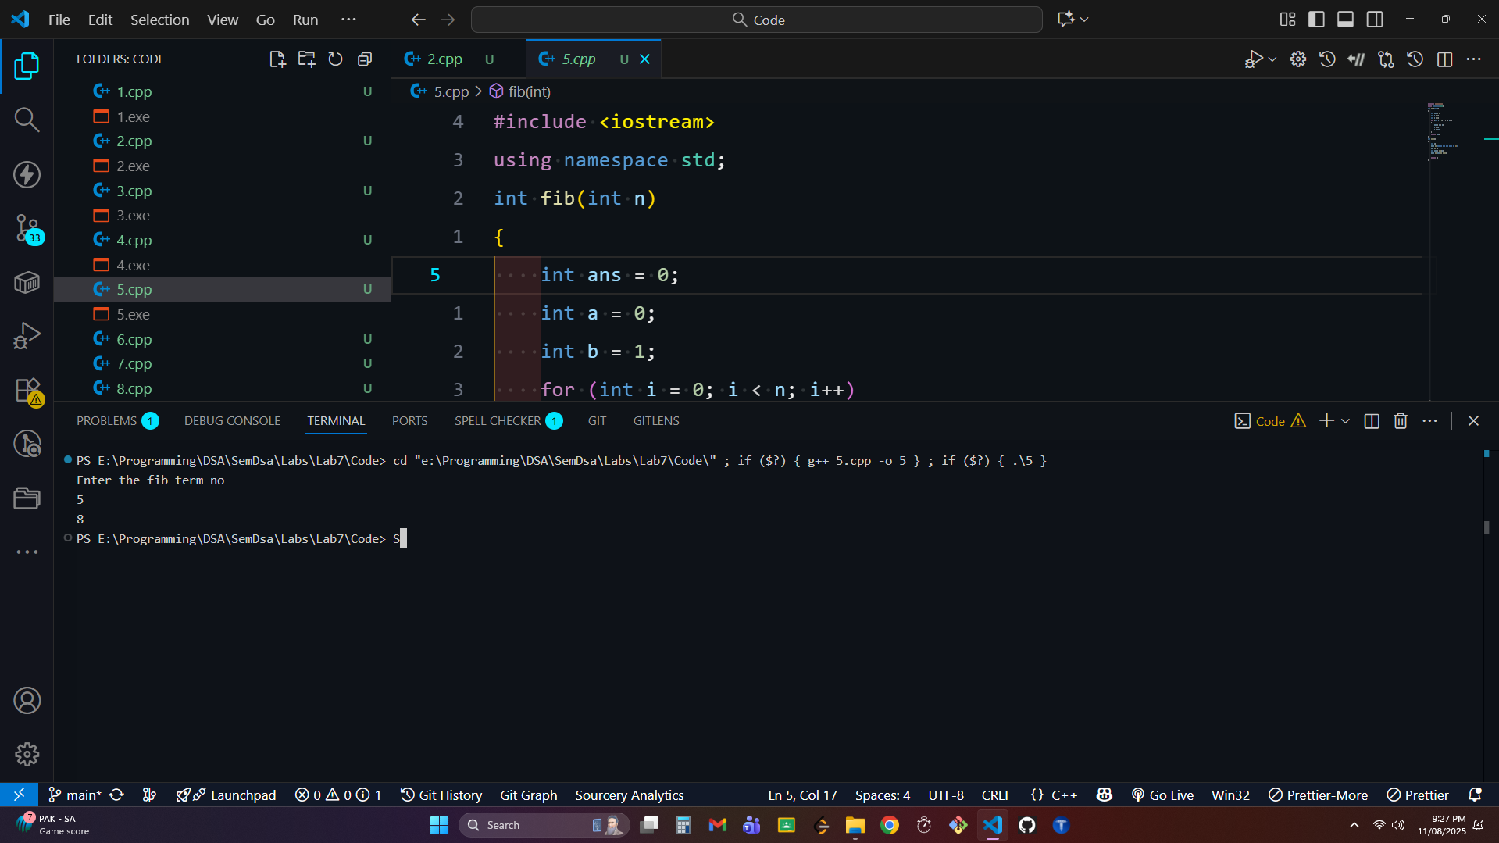

Exercise-6:

Now write another function FibonacciUsingRecursion which will generate up to the nth term of the Fibonacci sequence. Ask the user to enter a number and display the series up to that number. Use recursion method in the FibonacciUsingRecursion function to calculate the series.

Code :
#include <iostream>
using namespace std;
int fib(int n)
{
if (n == 1)
{
return 1;
}
if (n == 0)
{
return 1;
}
int ans = fib(n - 2) + fib(n - 1);
return ans;
}
int main()
{
int n;
cout << "Enter the no \n";
cin >> n;
int ans = fib(n);
cout << ans << endl;

return 0;
}

ScreenShot :


Exercise-7:

Write a function SumofDigits which will calculate the sum of numbers up to given limit. Ask the user to enter a number and calculate the sum of the numbers up to that number. Use iteration method in the SumofDigits function to calculate the sum.

Code :
#include <iostream>
using namespace std;
int sumOfnNumbers(int n)
{
int ans=0;
for(int i=1;i<=n;i++)
{
ans+=i;
}
return ans;
}
int main() {
int n;
cout<<"Enter the No \n";
cin>>n;
int ans=sumOfnNumbers(n);
cout<<ans<<endl;

return 0;
}

ScreenShot :
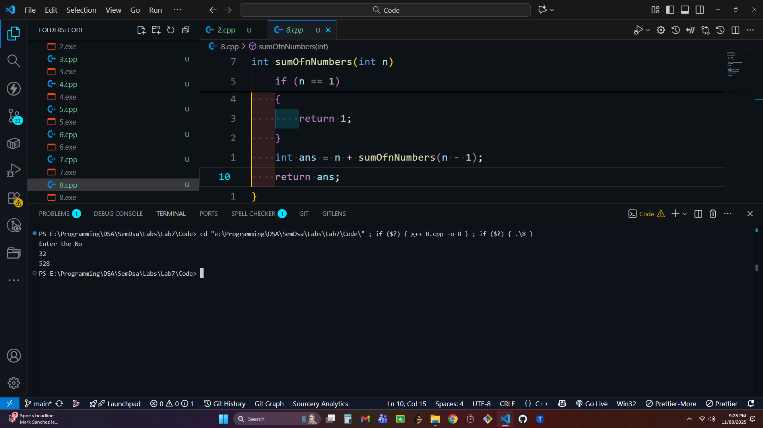

Exercise-8:

Now write another function SumUsingRecursion which will calculate the sum of numbers up to given limit. Ask the user to enter a number and calculate the sum of the numbers up to that number. Use recursion method in the SumUsingRecursion function to calculate the sum.

Code :
#include <iostream>
using namespace std;
int sumOfnNumbers(int n)
{
if (n == 1)
{
return 1;
}
int ans = n + sumOfnNumbers(n - 1);
return ans;
}
int main()
{
int n;
cout << "Enter the No \n";
cin >> n;
int ans = sumOfnNumbers(n);
cout << ans << endl;

return 0;
}

ScreenShot :
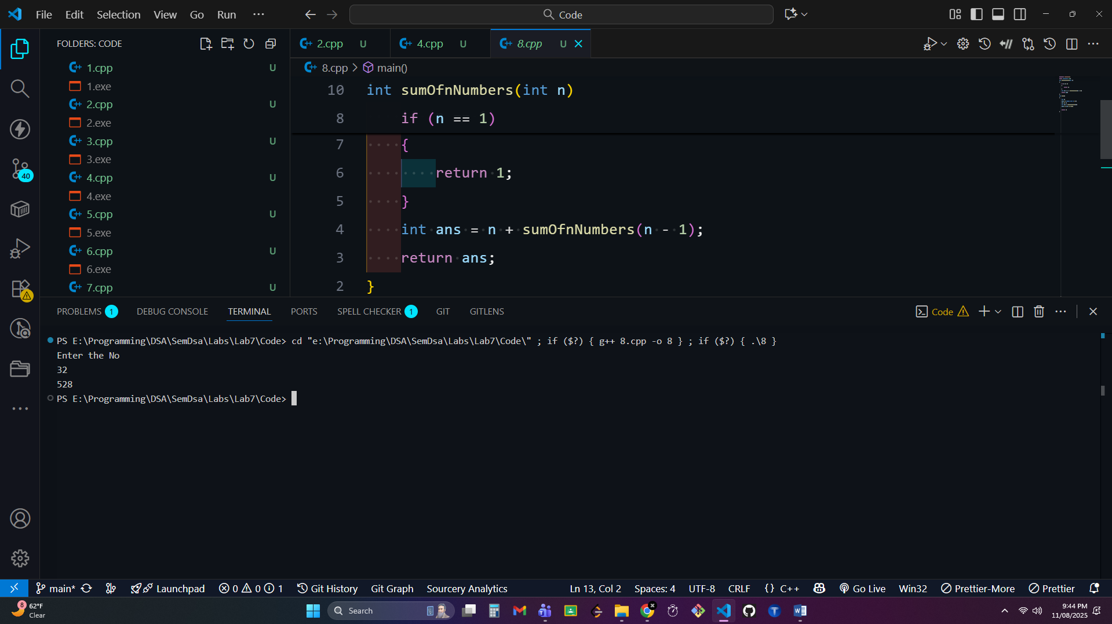
================================= End =================================

